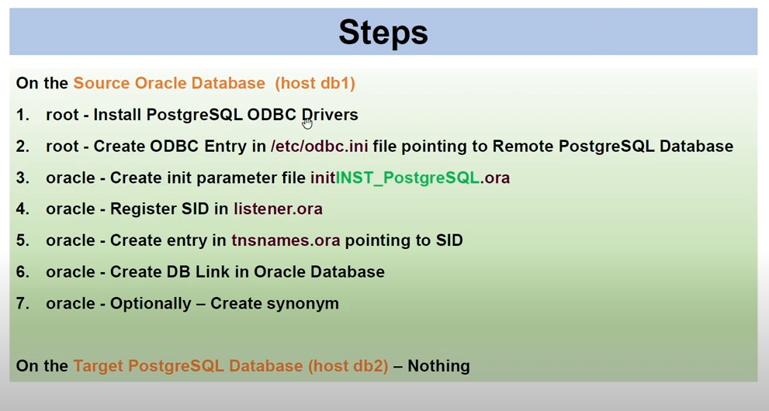

**rpm -qa | grep - ODBC**

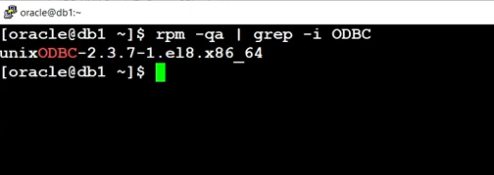

sudo dnf install -y https://download.postgresql.org/pub/repos/yum/reporpms/EL-10-x86_64/pgdg-redhat-repo-latest.noarch.rpm

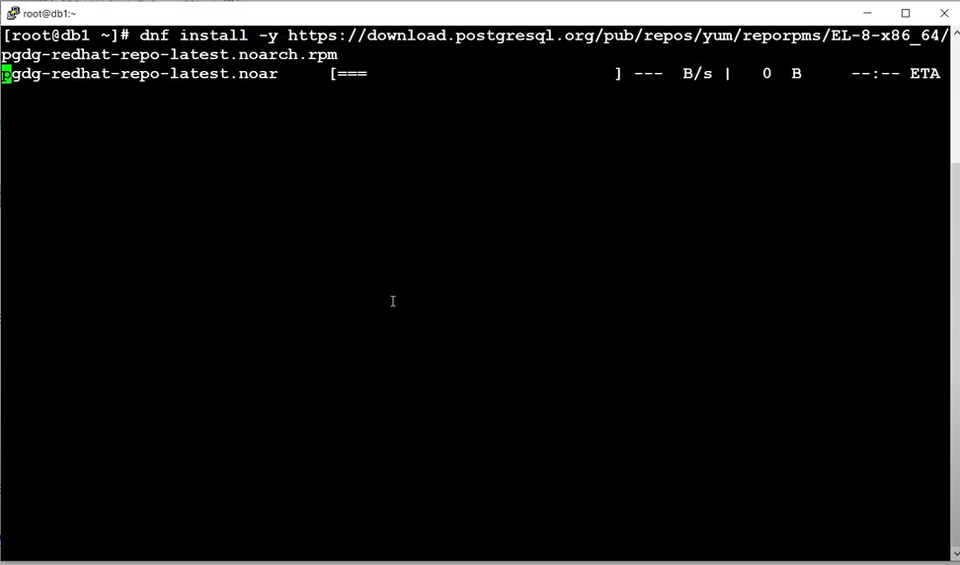

**rpm -qa | grep -i postgres**

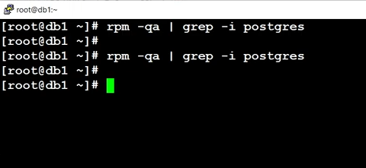

yum install -y postgresql17-libs

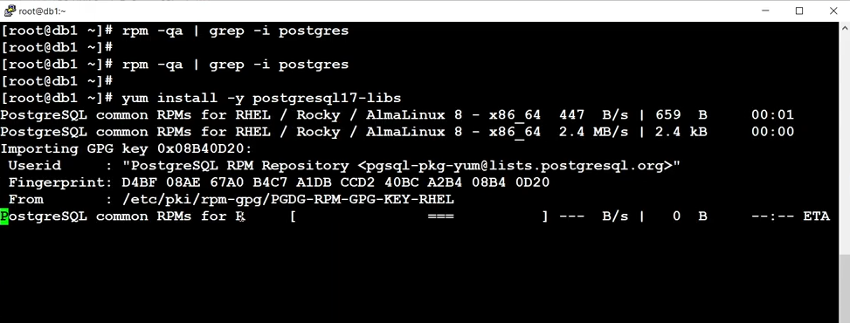

yum install -y postgresql17-odbc

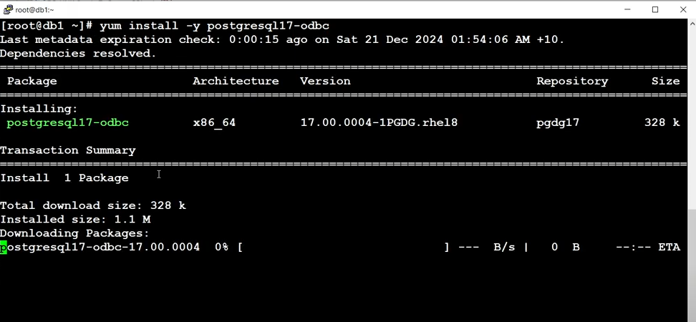

**rpm -qa | grep -i postgres**

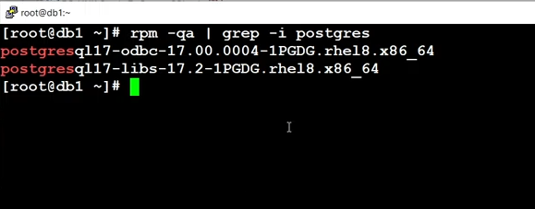

ls -l /usr/pgsql-17/lib/psqlodbc.so

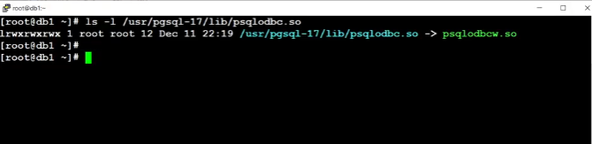

vi /etc/odbc.ini

[DS_PostgreSQL]

Description=POSTGRES

Driver=/usr/pgsql-17/lib/psqlodbc.so

Servername=db2

Port=5432

Database=test_postgres

username=postgres_user

password=password

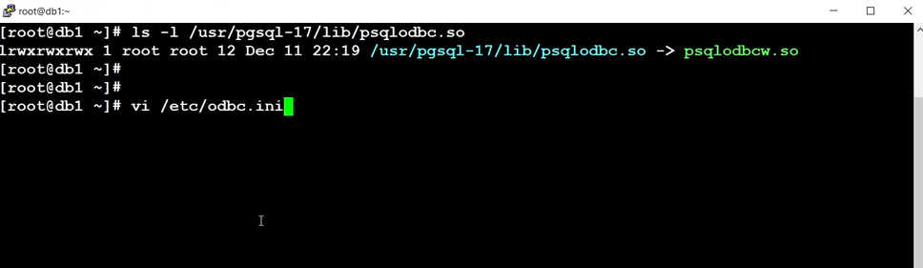

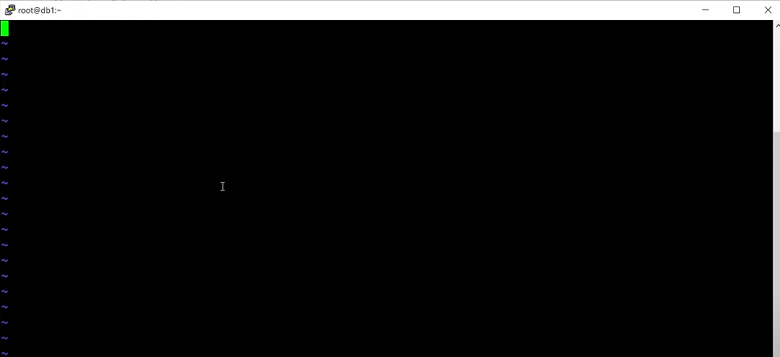

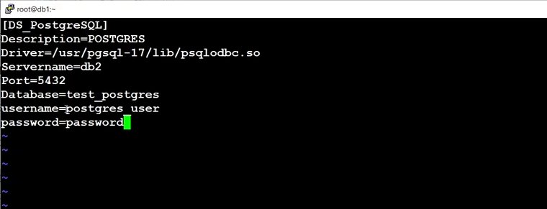

cat /etc/odbc.ini

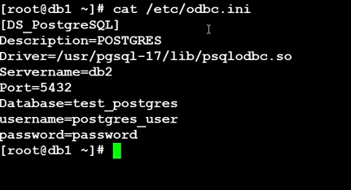

isql -v DS_PostgreSQL

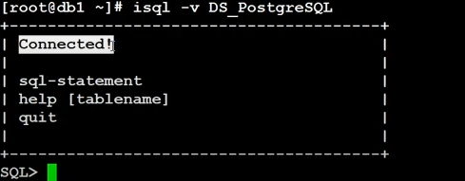

vi $ORACLE_HOME/hs/admin/initINST_PostgreSQL.ora

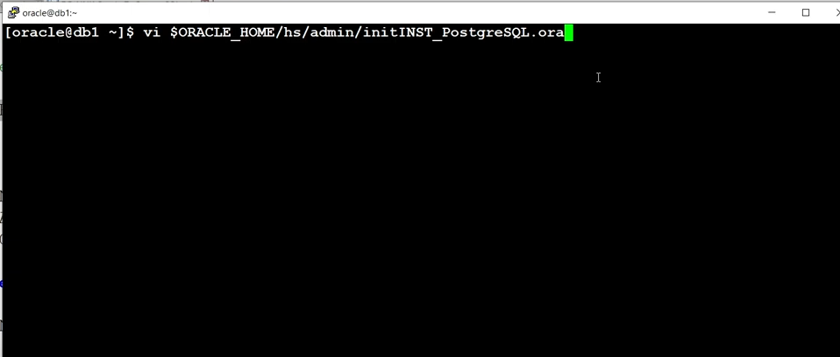

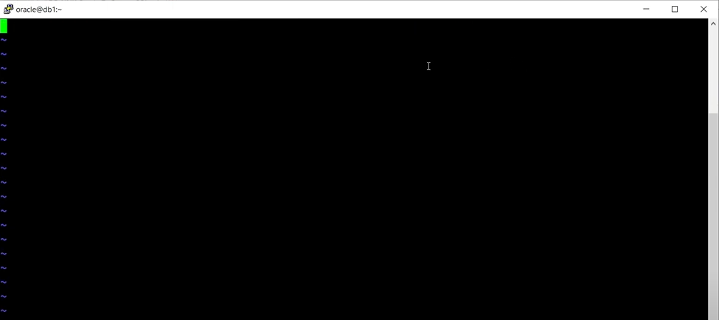

#HS init parameters

#

HS_FDS_CONNECT_INFO = DS_PostgreSQL

HS_FDS_SHAREABLE_NAME = /usr/pgsql-17/lib/psqlodbc.so

HS_LANGUAGE = AMERICAN_AMERICA.WE8ISO8859P1

#

# ODBC specific environment variables

#

set ODBCINI=/etc/odbc.ini

#

# Environment variables required for the non-Oracle system

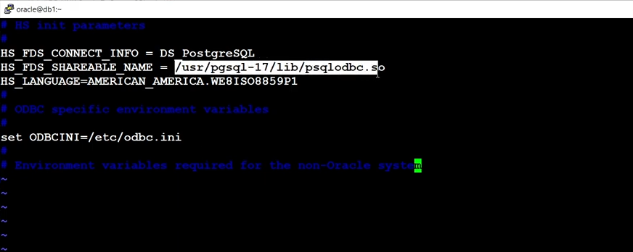

cat $ORACLE_HOME/hs/admin/initINST_PostgreSQL.ora

vi $ORACLE_HOME/network/admin/listener.ora

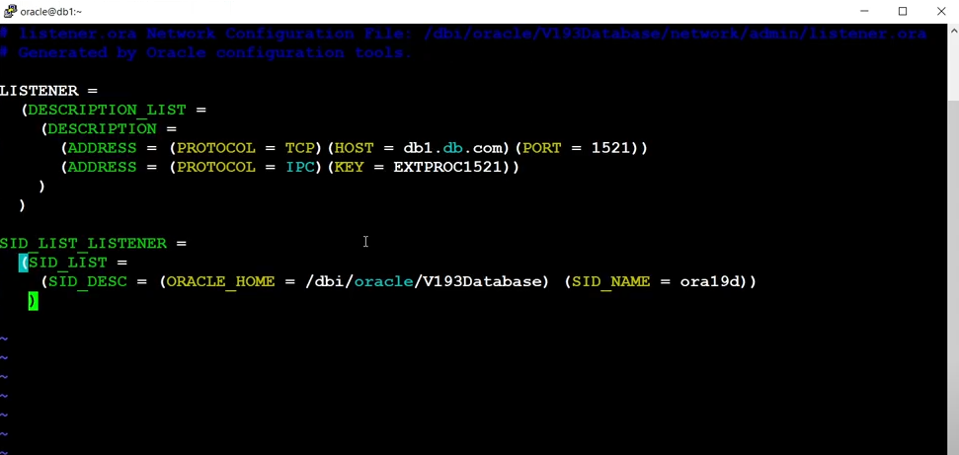

(SID_DESC = (PROGRAM = dg4odbc) (SID_NAME = INST_PostgreSQL) (ORACLE_HOME = /dbi/oracle/V193Database)

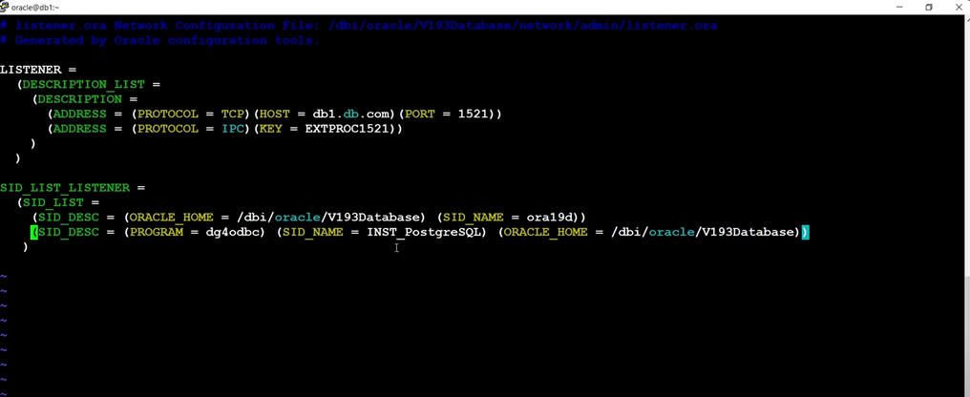

lsnrctl reload

lsnrctl status | grep PostgreSQL

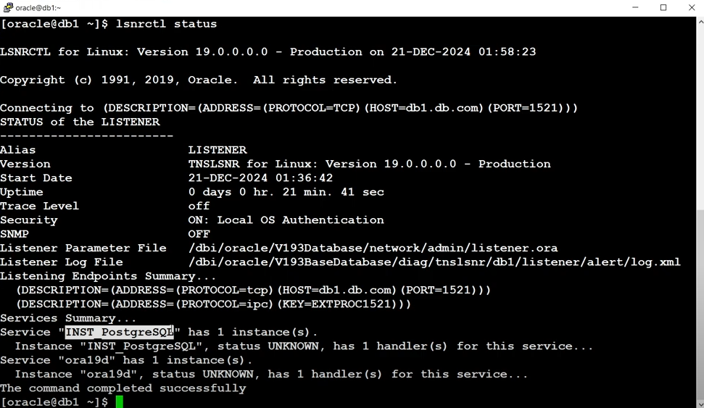

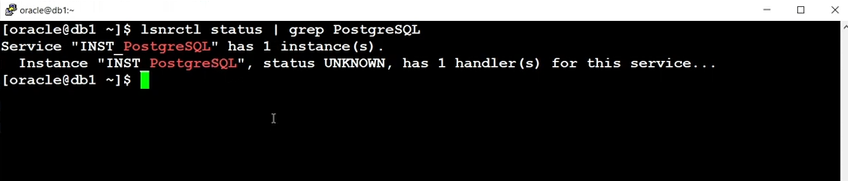

vi $ORACLE_HOME/network/admin/tnsnames.ora

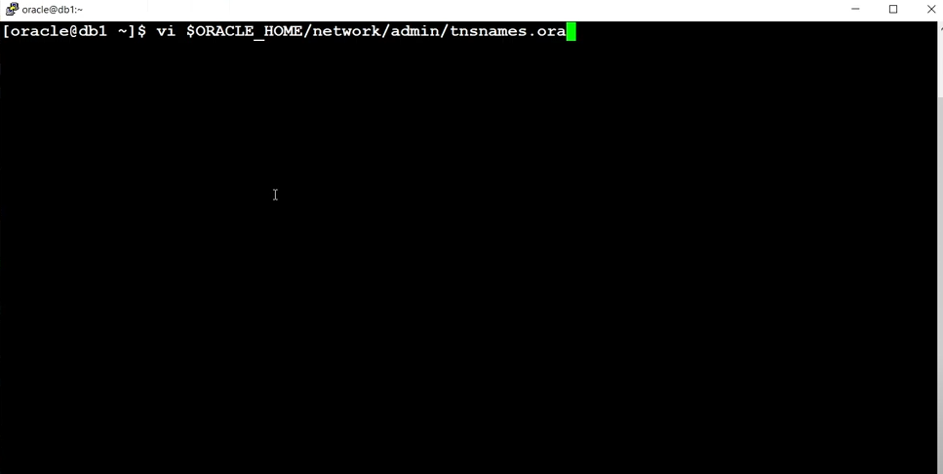

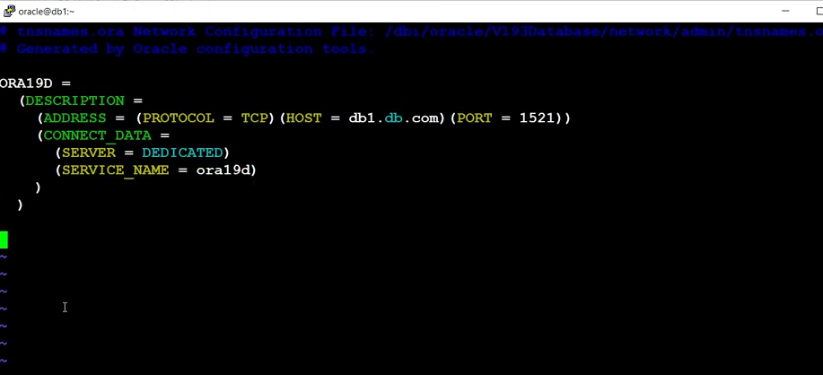

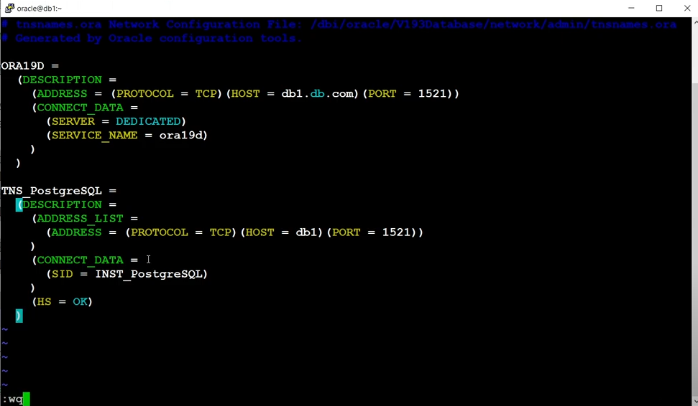

TNS_PostgreSQL =

(DESCRIPTION =

(ADDRESS_LIST = (ADDRESS = (PROTOCOL = TCP)(HOST = db1)(PORT = 1521)) )

(CONNECT_DATA =

(SID = INST_PostgreSQL)

)

(HS = OK)

)

tnsping TNS_PostgreSQL

